AimDK/AimRT Navigation/Locomotion Docs
Comtrade System Integration – AI/Robotics Team

Contents
LiDAR-Based Mapping: 4
Motor Controls: 6
Connecting to Motor Controller: 6
Gate 1 – Control Source: 7
Gate 2 – Action Mode: 8
Gate 3 – Planner Bounds: 9
Navigation Modules: 9
Debugging Codes: 12
Potential Issues/Things we will need to Address: 13
Blind Spots for LiDAR: 13
Intersection of People and Pathing: 13
Mapping Needing Ideal Conditions: 13
Navigation getting Confused: 14
Balance and Loss Thereof: 14
References: 15

The Agibot A2 Ultra utilizes AimRT, a ROS2 (similar) software that was created by Agibot for their applications and inclusion into the Agibot robots. The software includes many different modules that are configurable via .yaml files within the file system of the robot (located in ‘/agibot/software’), and allows developers to attain access to the robot’s software and change up the specific ways it works, without entirely changing the software or breaking the robot’s structure.

To get all the processes running within AimRT from inside of the robot, you will need to run the command:
aima em doctor

which will return the processes running, their status, and what their PID is. This is incredibly useful for debugging and the command should be used as a default by developers when checking the robot’s status or if something stops working.
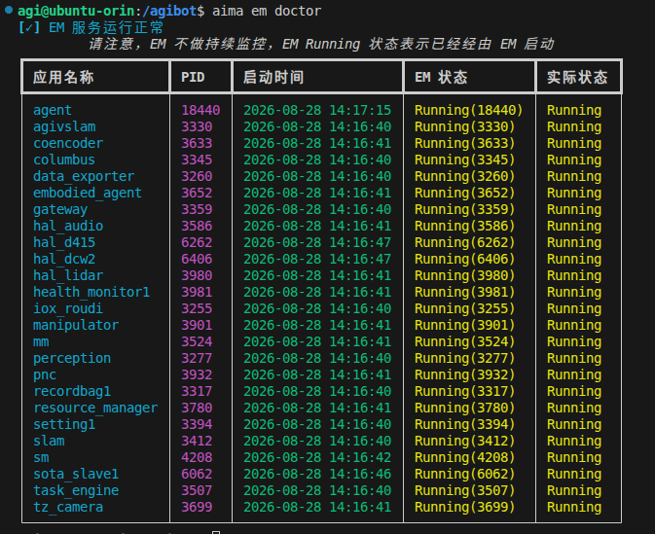
Text 1: aima em doctor output example

LiDAR-Based Mapping:
The A2 uses a powerful 360° LiDAR sensor (Livox Mid-360) in order to get a mostly-accurate depiction of the space around the robot. It is mounted in the “neck” area, where it is able to get a downward facing view of the surrounding space, allowing for a minimal amount of blind spots within the robot (there are a few, mentioned in a later section). It has a range of 40m in bad conditions (10% reflectivity of object), and about 70m in more ideal conditions (80% reflectivity), which makes it great for giving us the details of surrounding spaces.
The Agibot Remote Controller comes with a function that in the “Map” section that lets a user map an area around the robot. This function is within the robot’s own file system, and can be called manually, although it is a lot easier to use within the tablet, as the user gets more visual confirmation of what is happening (This is recommended for future uses of the mapping software for general applications → Only use the mapping inside of the robot itself if using it with some other specific code use).
The maps can also be accessed by the file system; they are saved inside of an SQLite database, titled “map.db” (‘/agibot/data/var/MapManagerModule’), and within this database we can access the different navigation objectives placed by the user, see the map itself, walls it built, paths it took, etc.
This is a useful tool for when we build our own software as well as for when we need to debug maps or send clients existing infrastructure or show off the technology to potential clients. Below is an attached map of a test we ran for the Comtrade SI main hall entrance, as well as the Hall of Fame:

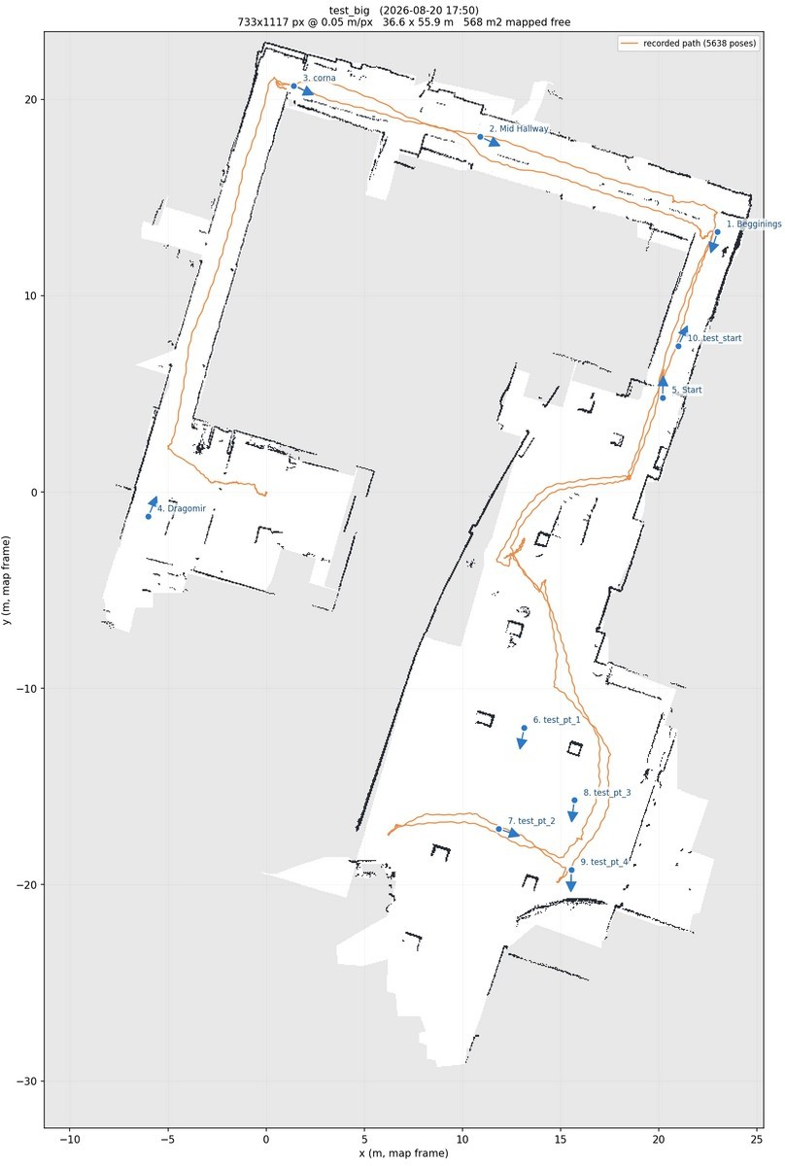
Figure 1: Example of LiDAR Mapping done by AimRT

Additionally, we have made code
(‘/agibot/humanoid-platform/robot_services/autonomous_navigation/testing_controls/a2_map.py’) which can give developers data and images of the maps, allowing for an easier time programming the maps and using them for our own development purposes.
These are the per-map files:

Name | File Extension | What it does
occupancy_map | .png/.yaml | Actual map
map | .pcd{"id": 1, "name": "Begginings", "pose": "{\"x\":23.0,\"y\":13.25,\"theta\": 4.395}", "type": 1} | 3D Coordinate measurements
keyframes | .pcd
frame_poses | .txt | (t, x, y, z, qx, qy, qz, qw) poses that the robot makes in its pathing and the navigation points.
trajectories | .txt | Trajectories the robot takes/has taken before.
grid_map_info | .txt | Special locations on the map (virtual walls, nav points, etc.)

NOTE 1: The Origin is TOP LEFT with v pointing DOWN, do not use ROS2’s formula, as it puts waypoints way off the real location. Use u = (x – ox)/res and v = (oy – y)/res

NOTE 2: occupancy_map.png is RGB with 3 colors, not the ROS2 occupancy image. In this case: (224, 229, 241) = free space
(157, 166, 189) = occupied space
(255, 255, 255) = unknown space

NOTE 3: The .yaml version of occupancy_map is BGR instead of RGB.

NOTE 4: The .yaml’s image: is an absolute path → DO NOT COPY THE FOLDER.

NOTE 5: resolution means two different things here: map_info = 20.0 px/m, yaml = 0.05 m/px. Trust the .yaml.

NOTE 6: map_version is unreliable → Order by map_id{"id": 1, "name": "Begginings", "pose": "{\"x\":23.0,\"y\":13.25,\"theta\":4.395}", "type": 1}

Motor Controls:

Connecting to Motor Controller:
The Motor Controller is on the address 192.168.100.100, which is the x86 PC which holds everything from WiFi addressing to the Motor Controller. Any and all commands made by the Jetson Orin AGX (192.168.100.110) must go through that part.
The ports that exist are (for sensors and motor controls):

Type of Transport | Where to Send | Reason
HTTP-RPC | Gateway (Jetson): 51056  Motor Controller: 56322  Arm Planner: 56321 | Sending Commands and Queries
ROS2 Topics | Domain ID: 232 | Getting Sensor Data
UDP | Motor Controller: 50041 | Locomotion Velocity

IMPORTANT NOTE: The ROS2 Domain ID is, by default 231, whereas the real ROS2 stack runs on 232.

The endpoint we write to is
http://192.168.100.100:56322/rpc/aimdk.protocol.<service>/<method>
which will send a command, however, it will be met with HTTP/200 and a code:0. The command will be received, but unless we are able to navigate through 3 gate checks, we essentially do nothing.
The robot has 26 controllable joints in the following ways:
- Legs: 6 per leg (idx 1-12) →hip_roll, hip_yaw, hip_pitch, tarsus, toe_pitch, toe_roll
- Arms: 7 per arm (idx 13-19 left arm; idx 20-26 right arm)
- Head: Fixed on the with_casing variant

Arm Joints in base_link (x – forward, y – left, z – up):

 | Joint | What is it | Notes
joint1 | Shoulder Flexion |  | 0 = hanging; +1.5708 =
 |  |  | horizontal forward; same sign
 |  |  | both arms;
 |  |  | Range is [-2.91, 2.91]
joint2 | Shoulder abduction |  | Home = +1.26 (left);  -1.26 (right)
joint3 | Upper arm roll
joint4 | elbow |  | [0.03, 2.0] Right;  [-2.0, -0.03] Left;
joint5 - joint7 | wrist |  | Parallel linkage, not in the URDF serial chain

NOTE: The joint1 range is different in the AimRT (Planner) and in the ROS2 (up to 2.967) → Planner bounds are authoritative in the grand scheme.

Request shape (McMotionService/PlanningMove):

{ "header": {"timestamp": {...}, "control_source": "ControlSource_SAFE"}, "group": "McPlanningGroup_DUAL_ARM",
"mode": "McPlanningMode_DEFAULT",
"target": {"type": "JOINT", "joints": [ ...7 or 14 values, radians... ]}, "param": {"velocity_scale": 0.12, "acceleration_scale": 0.12}
}

Gate 1 – Control Source:
The Control Source tells the robot what is sending the command; this is there partially so a stray command is not sent to the robot to perform. In the header of the command sent control_source must be equal to McBaseService/GetWorkMode, which for this robot, should be ControlSource_SAFE.

Gate 2 – Action Mode:
The McActionService/GetAction returns the robot’s current action. Two things are encoded in every action name at once:
McAction_ RL_LOCOMOTION_ARM_EXT_PLANNING_MOVE
- What the legs actually do
- What ARM interact is open

Below are the Leg and Arm inputs:

Prefix | Legs Output
PASSIVE_UPPER_BODY_* | MOTORS OFF → DO NOT DO THIS WITHOUT GANTRY!!!
RL_LOCOMOTION_ARM_EXT_* | Balancing and Walking.
RL_WHOLE_BODY_EXT_* | Whole body external control
DEFAULT | Post Bootup; Will accept nothing

Suffix | Accepts | Rejects
PLANNING_MOVE | PlanningMove (P2P) | Servo Streams
JOINT_SERVO | Continous joint-target stream | PlanningMove
ONLINE_PLANNING | Streamed trajectory queue | PlanningMove

So, for example, running something like RL_WHOLE_BODY_EXT_JOINT_SERVO is “arm-capable”, however, sending that a PlanningMove still fails, because the interface would be wrong. The position the robot is in determines what it can read, and it will often fail without giving a loud error.
The way to check the errors is in the Motor Controller (MC), where it’ll give something like:
[Warn][PncArmModule][pnc_arm_service.cc:85] current_action not right: RL_WHOLE_BODY_EXT_JOINT_SERVO

Gate 3 – Planner Bounds:
Every joint must be inside the planner’s range, which is not the URDF’s range. If any single joint is out of bounds, the entire goal is discarded. For example:

Joint Planner Range
Joint 1 (Shoulder Flexion) -2.91 → 2.91
Joint 4 right (Elbow) 0.03 → 2.00
Joint 4 left (Elbow) -2.00 → -0.03

NOTE 1: The Elbow can never be 100% straight.
To get error logs, it will log them in the MC as:
BoundsChecker: Invalid joint[3]: range: 0.03 2 q: 0 check goal: BoundsChecker is invalid

Navigation Modules:
The AimRT module for navigation is similar to Nav2 and its navigation stack, in that the robot uses the combination of LiDAR and VSLAM (Visual Simultaneous Localization And Mapping) in order to map its space and create a pathing from point A to B and adapt to any changes to the map that was originally built by the robot. The robot is able to navigate spaces, and can avoid obstacles as long as they are in the way far enough. It will also force a stop to itself in the event of someone appearing in front of it.
The robot does a great job moving through open areas, where it can freely maneuver and navigate. In more closed areas, however, it struggles due to it being very wide. During their development, the Agibot engineers have made it consider a 0.8 meter radius the amount it needs minimum to move through a space safely by default. However, as found in the config flies, we can change the “inflation radius” to get more desirable results.
In order to access the navigation modules via code, we need to access the gateway: http://127.0.0.1:51056/rpc/aimdk.protocol.PncService/<Method>
which has several different methods you can send in. The different methods will perform different actions, types of movement, etc.

Method Inputs Use
PlanningNaviToGoal map_id, target_id, Full planner to a saved
guide_line_id navigation point.
PlanningNaviToPose2D* SE2Pose** Planner to arbitrary coordinate.
DirectNaviToRelative SE2Pose** Straight to a relative pose
LinearNaviToGoal OR Linear motion
ToPose2D*
MobileNaviToGoal OR ToPose2D*
PreciseNaviToGoal target_id, pose_offset Fine docking
MoveForward angle, distance Open-loop
SpinTurn OR angle, [distance] SpinTurnAndMoveForward
ActionCancel OR Pause OR task_id Lifecycle Resume OR GetState
SetNaviParams Runtime tuning → No restart
CalculateNaviTime OR AutoExplore OR NoMapFollow OR RecordCurrentPose

*NOTE: The Pose2D variants of the methods exist on firmware but are absent from the SDK protos. There is no P2P for arbitrary coordinates that is a part of the normal SDK; this may be a feature that was planned by Agibot and unfinished, but it is part of the methods.
**SE2Pose = {position: {x, y}, angle} →In meters and radians

The lifecycle of sending the commands for navigation happens as follows:
send task_id → Poll ActionGetState → PncServiceState = IDLE/RUNNING/PAUSED/SUCCESS/FAILED

We are able to modify the parameters of specific aspects of the navigation modules ourselves within configs. The main one we’ve found for this so far is in
‘agibot/software/vectorflux_common/a2/app2.yaml’

where you can change several different configurations, making the robot more or less careful with things like speed, radius it will not move through, etc.; the below list contains some of the more important ones we’ve found:

Parameter Default Value What it does
footprint 0.672 (meters) Planner’s robot model approx size
spin_footprint 0.70 (meters) Robot model during rotation.
inflation_radius 0.8 Needs at least 1.6 meters to pass through a space.
cost_scaling_factor 5.5
inflation_by_lateral_width true Adds half-width on top
stop_dist_normal 1.2 (meters) Entire stop at this distance from people.
wait_change_path_delay_ms 2000 Waits 2 seconds on current path if stopped before replanning a path (We may want to reconsider this)
slowdown_dist_normal 2.5 (meters) Slows down at this distance to an obstacle in its way.

NOTE 1: This config is read only at the startup. Vectorflux runs as app named ‘pnc’ in aima. To reset this, you will need to run:
aima em reset-app pnc OR
aima em stop-app pnc → aima em start-app pnc

NOTE 2: For the inflation_radius variable (at least this one we tried changing), there are several instances of it in the .yaml file, all of which change the variable for different parts of the navigation module. When changing anything in the navigation module, check if there are

multiple instances and for what by doing CTRL+ F to find multiple instances, and please document what is changed where.

NOTE 3: IF THE NAVIGATION CONFIG NEEDS TO BE UPDATED!!! → PLEASE DO NOT DO IT WHILE THE ROBOT IS STANDING ON ITS OWN!!! THIS CAN CAUSE THE ROBOT TO FALL IF IT IS IN SPECIFIC STANDING MODES!!!

Debugging Codes:

Symptom Gate to Check Where to Check
HTTP 200, code 0, nothing 1 or 2 GetWorkMode, GetAction
happens
‘current_action not right’ 2 /agibot/log/pnc_arm/ pnc_arm.log
‘BoundsChecker is invalid’ 3 Same as above ^^
HTTP 500, code 1002 RPC registered but not implemented on this build (JointControl, SafeStop, GetWorkState are all 1002)
HTTP 404 No Method like that exists
task_id always 0 MC proxies arm moves to
pnc_arm:56321 and never returns the real id → verify by polling GetJoinState for convergence.

Potential Issues/Things we will need to Address:

Blind Spots for LiDAR:
There are spots near the shoulders and behind the battery pack which can be blind spots for the LiDAR, especially for small children and animals; → While the robot is unlikely to encounter these specific beings, it can carry devastating consequences if an 80kg robot was to hit, step on or accidentally fall onto a small child or animal

One way to address this issue is to add more sensors onto the robot’s blind sides (here we can get away with some kind of arched ultrasonic sensors at the robot’s hips or underneath the battery in the 4 directions around the robot (front, left, right, and behind)) which would give us more guarenteed safety. The other method is a predictive algorithm for where something might be based on known information (shadows, size of object, potential behaviors). Finally, we can just have the robot perform a safe stop (slowdown and stop) when it detects something went into the blind spot (this is the easiest to perform).

Intersection of People and Pathing:
AimDK has software that detects objects around it, but the robot does not seem to do anything about this. What I propose we do is add an algorithm that will detect if an object is about to intersect with the robot (we can use the LiDAR detections of objects, perform a linear prediction, and course correct if a collision is imminent). This will provide us with safety features that will make the robot’s travel time a lot less stressful and allow us to be more hands-off.

Mapping Needing Ideal Conditions:
During mapping, areas with moving objects can be made to look like permanent objects, thus changing the pathing algorithm. We need to either do a local vs global costmap which would update the global one at all times, or figure out a better solution.
For the initial mapping, we will either need to map it when there’s no people/anomalies in the path, or we will need to design a script to remove fake or incorrect data from the LiDAR map based on multiple scans, general patterns etc.
We can also just make a code to manually remove the data from the map.

Navigation getting Confused:
If it gets into a tight corridor or space, it can get stuck and not be able to move. This means that the conditions for actual movement through a space need to be ideal. The robot cannot move through spaces that are tight without extreme freeing of conditions like the inflation_radius, which even then provides issues.
I propose we make our own software for this case, which will act as a form of confirmation for the robot’s pathing, where the camera will perform detections of the path the robot wants to take, compare it with the LiDAR mapping, and see if there actually is something in the way or if there is actually no way for the robot to proceed through an area. If so, it’ll send out a distress signal to us, otherwise, it’ll try to move through the area but incredibly slowly for safety reasons.

Balance and Loss Thereof:
Robot hitting into anything or performing a weird movement of the legs (for example, someone bumps into it and pushes it), it can cause the low-level motor controls to stop, forcing people to reset the robot entirely (E-Stop needs to be pressed in order to reset it).
This should be kept but we should make an algorithm for the robot to (at the very least) make a loud noise if it detects an imminent collision it cannot avoid by itself, as a last ditch attempt to avoid it. If it can, our algorithm should guide the robot away from the potential collision and into safety, overriding the pathing algorithm towards the route, and instead focusing on the safety of itself and others temporarily, waiting until it is out of danger before going back towads the main path.

References:
Livox Mid-360 LiDAR Specs: https://www.livoxtech.com/mid-360/downloads

